**Chapter - 1**

**Project Definition**

**1.1 Aim of project:**

Our project includes a game in C++ named “ KBT-The Quiz Game ”. This simple quiz game creates a gaming environment and expand your computer based knowledge with just few basic software requirements.

**1.2 Purpose:**

To play a game that enhances the knowledge.

**1.3 Scope:**

We can take exams in school or college with use of this project . we can make a game of general knowledge with use of this project.

**Chapter - 2**

**Description**

Knowledge is power. Test your hardware and software based knowledge! This is a multiple choice quiz. You can compare your knowledge with the rest of the world.

First of all, user have given a software file (.exe) , so that the security of the code is maintained and there is no chance of any changes in code . We have created a game in C++ in which user can play it through keyboard.

**How to Play:**

First you have to submit your name and id number.

This is a multiple choice quiz game , so you have to choose 1 answer from given 4 options.

If your answer is correct then you are given 5 points.

After answering all the questions your total score will be shown.

**Chapter - 3**

**Requirements**

**Hardware Requirements**

* + - * RAM : 1 GB or above
      * Processor : Intel Core 2 duo or above

**Software Requirements**

* + - * Operating System: Windows 7 or above
      * Front End : Codeblocks

**Chapter - 4**

**Major Features**

The game is packed with different question based on hardware and software of computer system giving you power of knowledge.

We have a separate text file which consists of all questions and options. So only developer can change the questions and options whenever they want.

Another main feature of our project is that we have given a .exe file, with which user can only have access to the game. With the help of this, no one can make changes of any kind in the coding of the game so there is no chance of cheating.

We also have a data file which keeps record of the Name , Id and Marks of every user.

**Chapter - 5**

**Flow Chart**

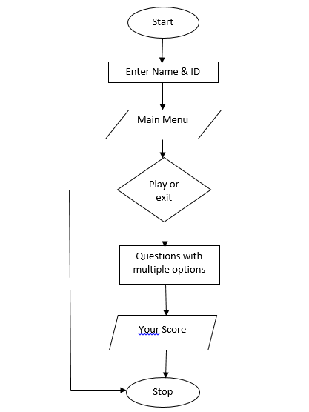

**Chapter - 6**

**Screenshots of Project output**

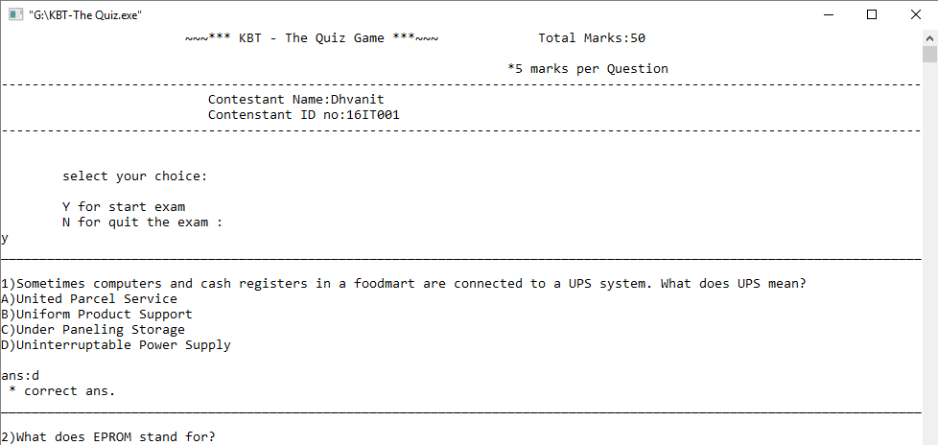

In this screen shot we are shown the starting output of our project. First it asks the user to input his/her name and ID. After that it asks to play or exit the game. If you enter y then the game starts. One by one questions and their 4 options are given to you , you have to select one of the option by entering from keyboard. After giving each answer it shows that answer is correct or not.

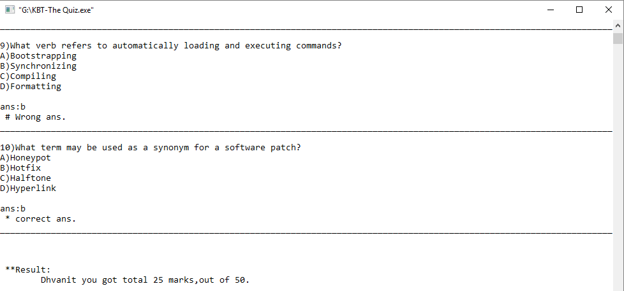

In this screen shot we are shown the ending output of our project . After the end of whole quiz , it shows the total score.

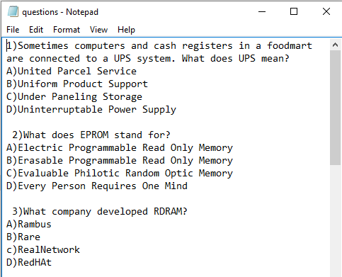

In this screen shot we are shown the output of file which have questions and options.

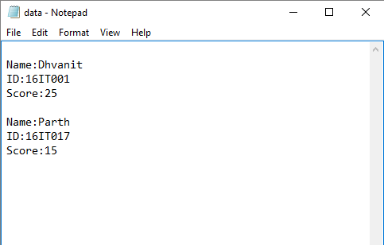

In this screen shot we are shown the output of file which maintains data record (Name , Id , Score ) of every users that played this game.

**Chapter - 7**

**Limitations of Project**

Main limitation of our project is that we cannot add graphics to our project as if graphics are added then the software and hardware requirement changes .

**Chapter- 8**

**Outcome**

**Self Analysis of Project Viabilities**

In this project we learnt some basic concepts of C++ including file handling.

**Project Effort and Time**

Every member of team has given his time to learn and explore coding in C++.

Every member have given their time 3 hours weekly in this project. Every member had worked on this project equally.

**Chapter - 9**

**Future Enhancement**

In future, we would like to add graphical user interface and attracting features which are different from this interface.

We would like to develop mobile app in different platforms for making it easier and beneficial to user.

We would also like to add different gaming soundtracks in this game.

**Chapter - 10**

**References**

Book:

Object Oriented Programming in c++ by E balagurusamy

Websites:

cppprojectcode.blogspot.in

www.tutorialspoint.com

geeksforgeeks.org